Interest and Principal Payment Calculation - Full Answer
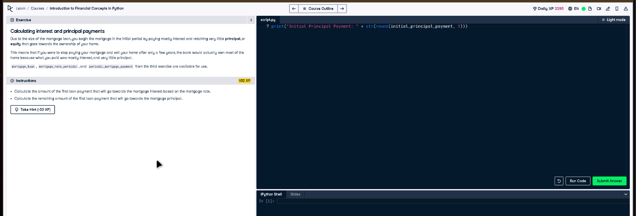

Full Code Answer:
# Given variables
# mortgage_loan, mortgage_rate_periodic, and periodic_mortgage_payment are provided.
# Calculate initial interest payment
initial_interest_payment = mortgage_loan * mortgage_rate_periodic
# Calculate initial principal payment
initial_principal_payment = periodic_mortgage_payment - initial_interest_payment
print("Initial Interest Payment: " + str(round(initial_interest_payment, 2)))
print("Initial Principal Payment: " + str(round(initial_principal_payment, 2)))

Question:
Calculate the amount of the first loan payment that goes towards the mortgage interest and principal.

20-word Explanation (Question):
Each mortgage payment is split between interest and principal. The initial payment has a higher interest component and lower principal.

Answer:
The interest portion is mortgage_loan * mortgage_rate_periodic, and the principal portion is periodic_mortgage_payment minus this interest.

20-word Explanation (Answer):
We calculate the interest portion first using the current balance and rate, then subtract it from the payment for principal.

